23BD1A05B3 – M.SRILAKSHMI

Roles

Procedure: Attaching a Role to an EC2 Instance

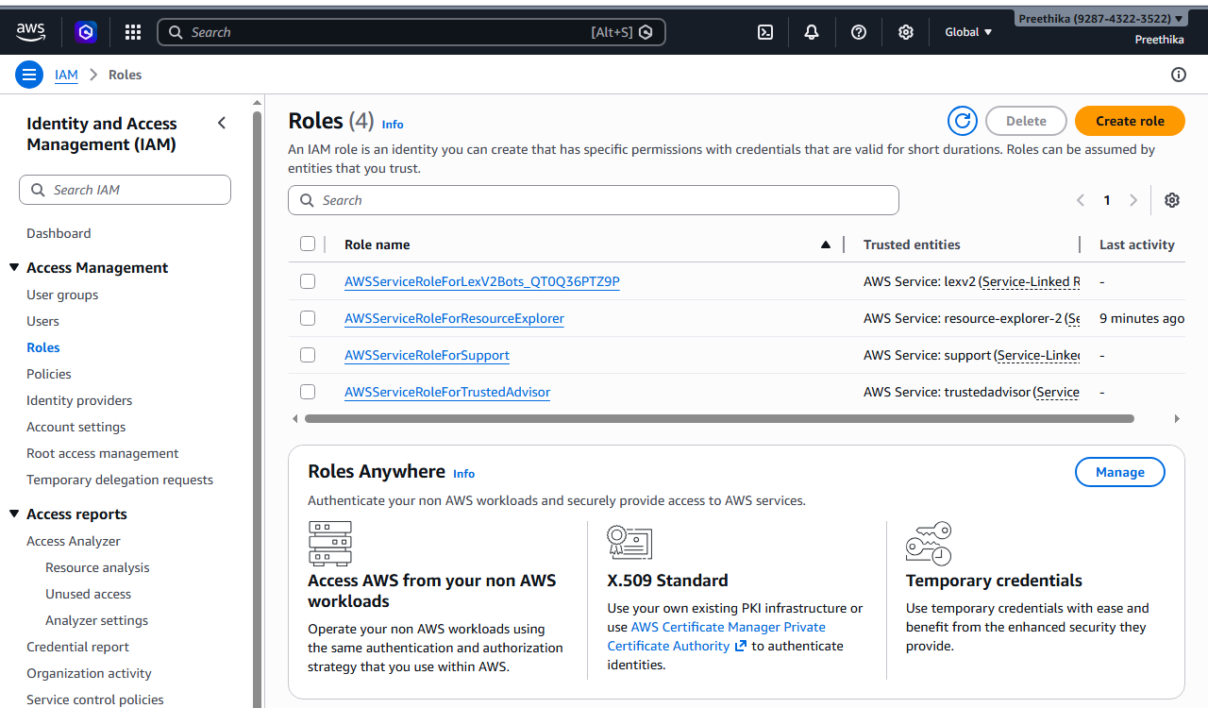

Create the Role: Go to IAM > Roles > Create role

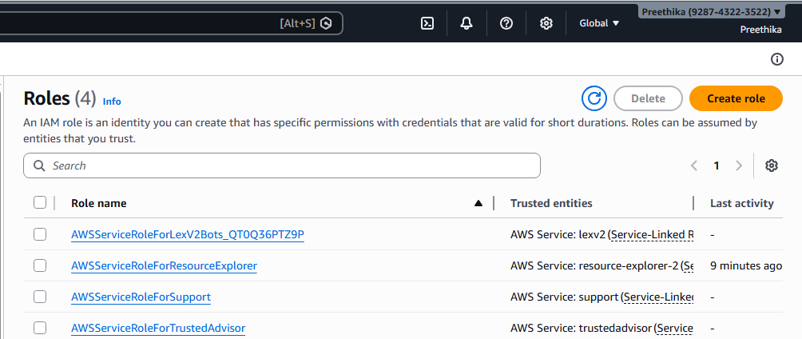

Select Trusted Entity: Choose AWS Service.

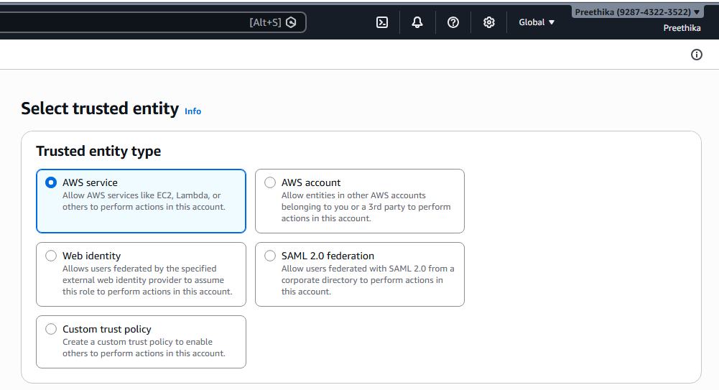

Under the "Service or use case" dropdown, select EC2. (This tells AWS: "I trust the EC2 service to use this role").

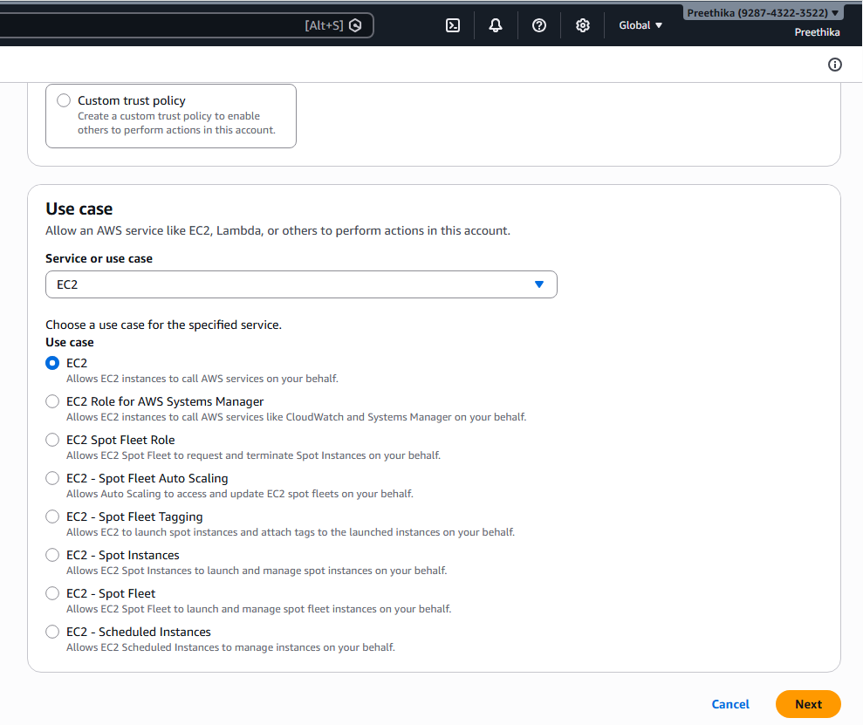

Add Permissions: Search for and check AmazonS3FullAccess.

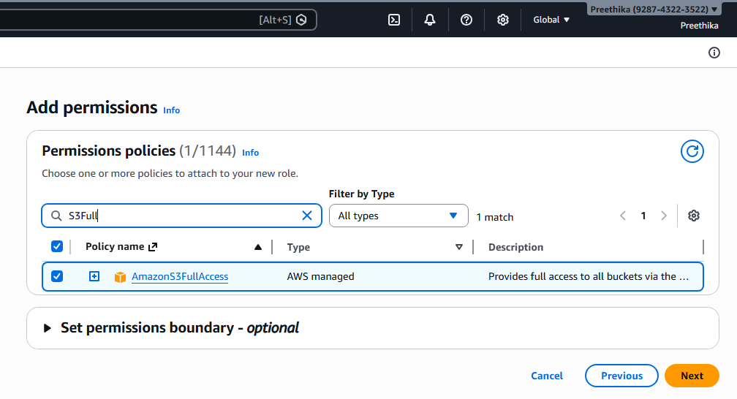

Name & Review: Name it (e.g., EC2-S3-ReadOnly-Role) and click Create role.

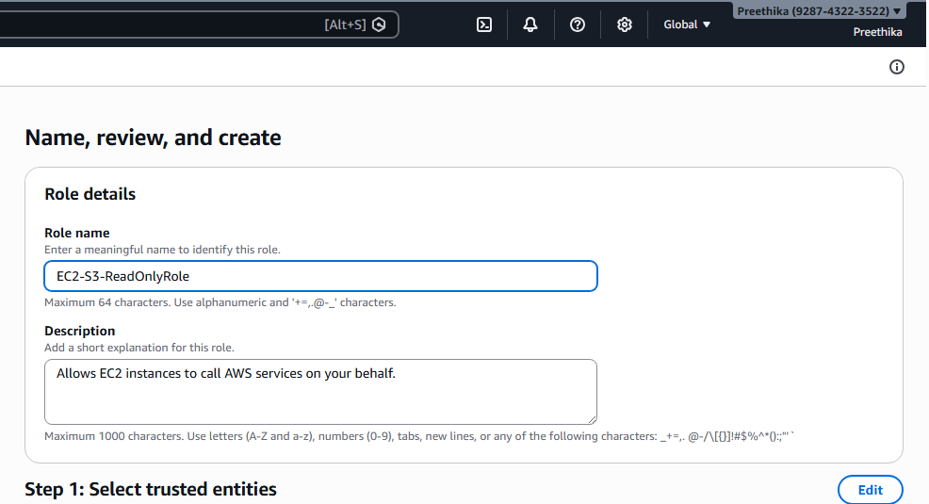

Name & Review: Name it (e.g., EC2-S3-ReadOnly-Role) and click Create role.

Role has been created

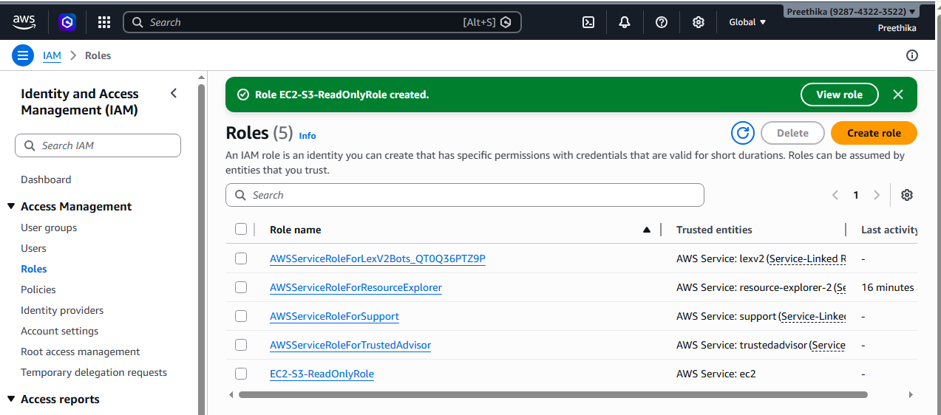

Create the ec2 instance and and connect to it and check for aws ec2 describe-instances
Attach to Instance:
Go to the EC2 Dashboard. Select your running instance.
Click Actions > Security > Modify IAM role.
.
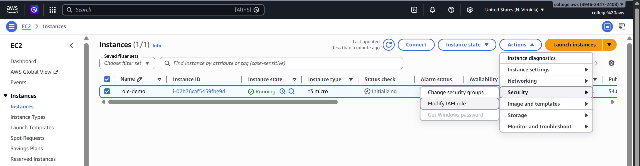
Select the role you just created and click Update IAM role
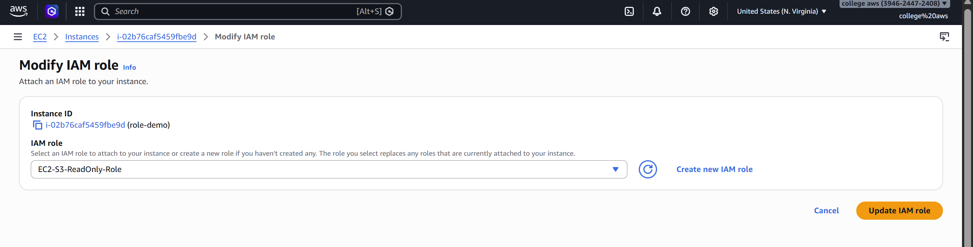

Verify via CLI:
SSH/Connect into your EC2 instance. Type aws s3 ls.
The Result: The command works immediately.

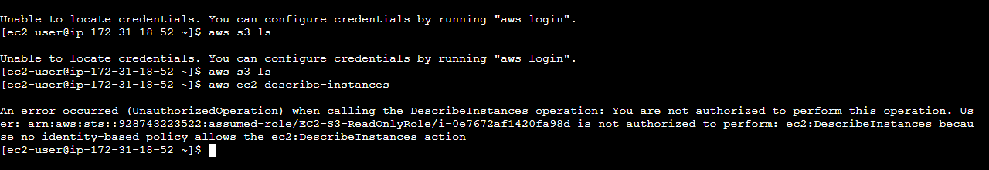

We can here role has only s3 full access only here-- aws ec2 describe-instances –
unauthorized

You did not have to provide an Access Key or Secret Key. AWS automatically provided
Temporary Security Credentials to the instance.
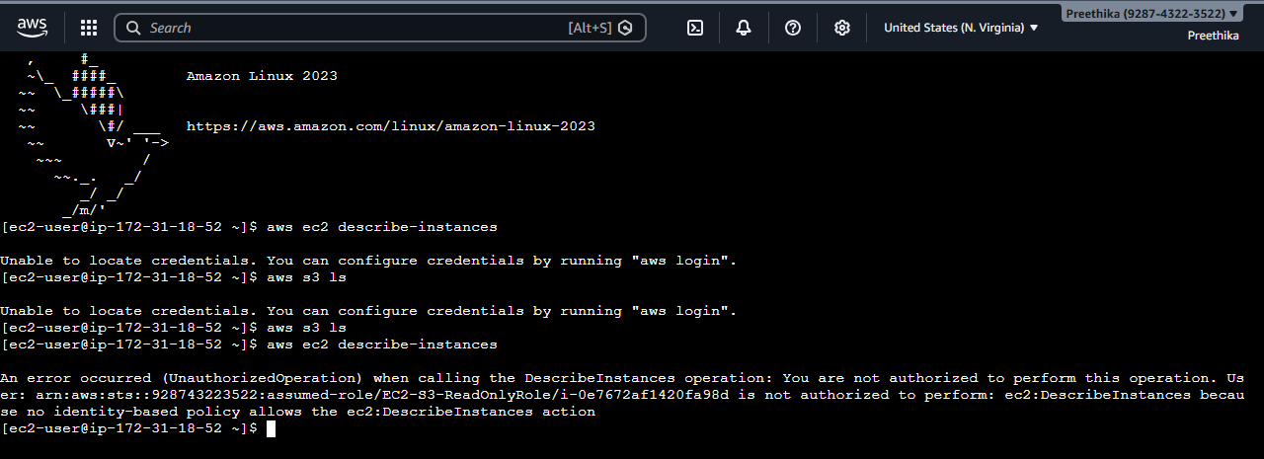

Scenario based questions:

1. Scenario: New Developer Access
You hired a new developer who needs access to EC2 and S3.
Question: How will you provide access?
A: Create an IAM user in AWS Identity and Access Management and attach policies that allow required access to EC2 and S3, preferably through a group.

2. Scenario: Temporary Access Needed
A user needs access only for 2 days. How to do this?
A: Provide temporary access using IAM roles with STS (Security Token Service) and set an expiration time of 2 days.

3. Scenario: Access Key Leak
A developer accidentally exposed access keys on GitHub.How to resolve this?
A: Immediately deactivate and delete the exposed access keys, create new keys, and rotate credentials while reviewing logs for misuse.

4. Scenario: CLI Access Required
User needs programmatic access. How to do this?
A: Create an IAM user with programmatic access and generate access key ID and secret key for AWS CLI usage.

5. Scenario: 50 Employees Same Permissions
50 employees need same S3 access. How to do this?
A: Create an IAM group, attach the required S3 policy, and add all 50 users to that group.

6. Scenario: Change Permissions for Multiple Users
You need to revoke access from 20 users. How to do this?
A: Modify or detach the policy from the IAM group or bulk update policies instead of changing each user individually.

7. Scenario: Different Departments
HR, Dev, Admin need different access. How to do this?
A: Create separate IAM groups (HR, Dev, Admin) and assign different policies based on their roles.

8. Scenario: EC2 Access to S3
An EC2 instance needs access to S3 without credentials.How to do this?
A: Attach an IAM role with S3 permissions to the EC2 instance so it can access S3 without using access keys.

9. Scenario: Cross-Account Access
Account A wants to access resources in Account B. How to do this?
A: Use IAM roles with a trust policy in the target account to allow users or roles from another account to assume it.

10. Scenario: Lambda Access to DynamoDB
Lambda needs to read/write DynamoDB. How to give this?
A: Attach an IAM role with DynamoDB permissions to the Lambda function.

11. Scenario: Temporary Elevated Access
Admin access needed temporarily. How to do this?
A: Grant temporary admin access using IAM roles with limited session duration and revoke after use.

12. Scenario: Restrict S3 Access to Specific Bucket
User should only access one bucket. How to do this?
A: Grant temporary admin access using IAM roles with limited session duration and revoke after use.

13. Scenario: Deny Delete Actions
Users should not delete resources. Why this happens?
A: Apply an explicit “Deny” policy for delete actions, which overrides any allow permissions.

14. Scenario: Time-Based Access
User should access only during office hours. How to do this?
A: Use IAM policy conditions with time restrictions (e.g., aws:CurrentTime) to allow access only during office hours.

15. Scenario: IP-Based Access
Allow access only from office network. How to do?
A: Use IAM policy conditions with aws:SourceIp to restrict access to specific office IP ranges.

16. Scenario: Secure Best Practice
How do you manage permissions efficiently?
A: Follow the principle of least privilege, use IAM roles instead of users where possible, and manage access via groups and policies.

17. Scenario: Root User Usage
When should root user be used?
A: Use the root user only for critical account-level tasks like billing, account settings, and initial setup.

18. Scenario: Multiple Services Access
User needs EC2 + S3 + DynamoDB. How to do this?
A: Attach multiple service permissions (EC2, S3, DynamoDB) in a single IAM policy or combine managed policies and assign to user/group.

19. Scenario: Audit Permissions
How to track user activity?
A: Use AWS CloudTrail to monitor and track all user activity and API calls.

20. Scenario: Over-Permission Issue
User has too much permission. How to solve this?
A: Review and reduce permissions by applying least privilege, removing unnecessary policies, and using IAM Access Analyzer.

